Hospital Management System
UCS310 – Database Management Systems

B.Tech (2nd Year)
Thapar Institute of Engineering & Technology

Group Members
1. Ishaan Mishra - 1024030346
2. Samyak Bhushan - 1024030344
3. Chetanya Chawla – 1024030351

Lab Instructor Name: Dr Amrita
Academic Year: 2025–26

Introduction
The Hospital Management System (HMS) is a database-driven application designed to manage hospital operations such as patient records, doctor details, appointments, treatments, and billing information.
Traditional manual or file-based systems lead to redundancy, inconsistency, and operational inefficiencies. A Database Management System ensures structured storage, data integrity, security, and efficient retrieval.
This project emphasizes backend implementation using SQL and PL/SQL for robust database design and management.

Problem Statement
Hospitals require systematic management of patient data, doctor information, appointments, treatment records, and billing processes.
Limitations of existing/manual systems include:
- Data redundancy and inconsistency
- Difficulty in retrieving records
- High chances of human error
- Lack of centralized control and security

Objectives of the Project
- To design a database using Entity–Relationship (ER) modeling.
- To convert ER model into relational tables.
- To apply normalization up to 3NF/BCNF.
- To implement the database using SQL.
- To use PL/SQL constructs such as procedures, functions, triggers, and cursors.
- To ensure data consistency using constraints and transactions.

Scope of the Project
Modules included:
- Patient Management
- Doctor Management
- Appointment Scheduling
- Treatment Records
- Billing System
Types of users involved: Administrator, Doctor, Receptionist/Staff.

Proposed System Description
The system maintains centralized data where patients are assigned unique IDs, doctors are categorized by specialization, appointments link patients and doctors, treatments are recorded per visit, and billing is generated automatically.
Key Features:
- Centralized database system
- Secure data storage with integrity constraints
- Automated billing using triggers
- Efficient reporting using SQL queries
- Reduced redundancy through normalization

Normalization
The database is normalized up to Third Normal Form (3NF) to eliminate redundancy and ensure consistency.

Database Design
Entities: Patient, Doctor, Appointment, Treatment, Billing.
Relational Schema includes primary keys and foreign keys to enforce referential integrity.

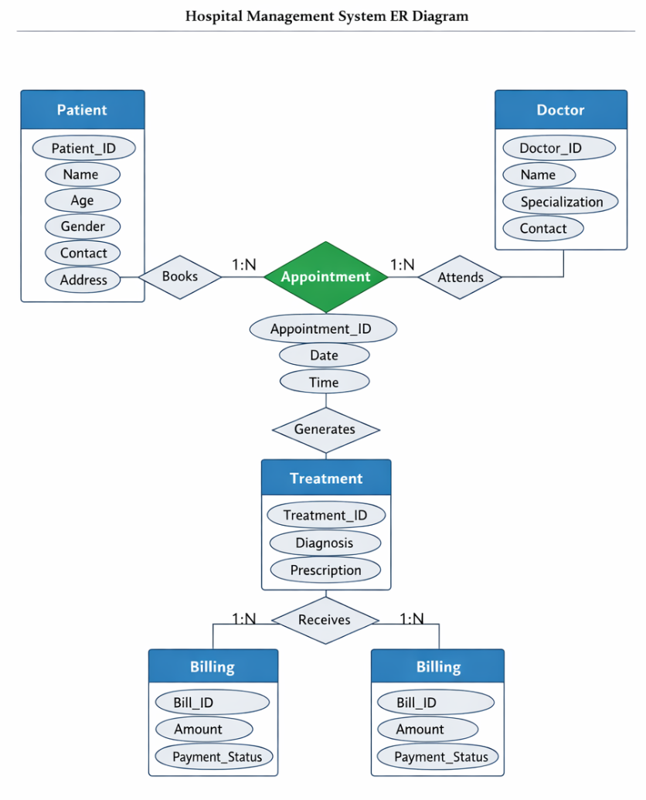

Database Implementation
SQL Implementation includes DDL, DML, joins, subqueries, aggregate functions, GROUP BY, HAVING, and views.
PL/SQL components include stored procedures, functions, triggers, cursors, and exception handling.

Transaction Management & Concurrency
The system uses COMMIT, ROLLBACK, and SAVEPOINT to maintain ACID properties and ensure data consistency.

Tools & Technologies Used
DBMS Software: Oracle / MySQL
Language: SQL and PL/SQL
Interface Tool: SQL Developer / MySQL Workbench

Expected Outcomes
- Creation of a normalized relational database
- Efficient data retrieval using optimized SQL queries
- Automation using procedures and triggers
- Improved data consistency and integrity
- Reduction in manual errors

